Test Case: tc002_SPX_Dev5_Crear_Requisicion_Spot_Con_FAD_Tipo_Cobro_CC
Step 1 - Enter username and password and click to button Enter : Credentials Entered
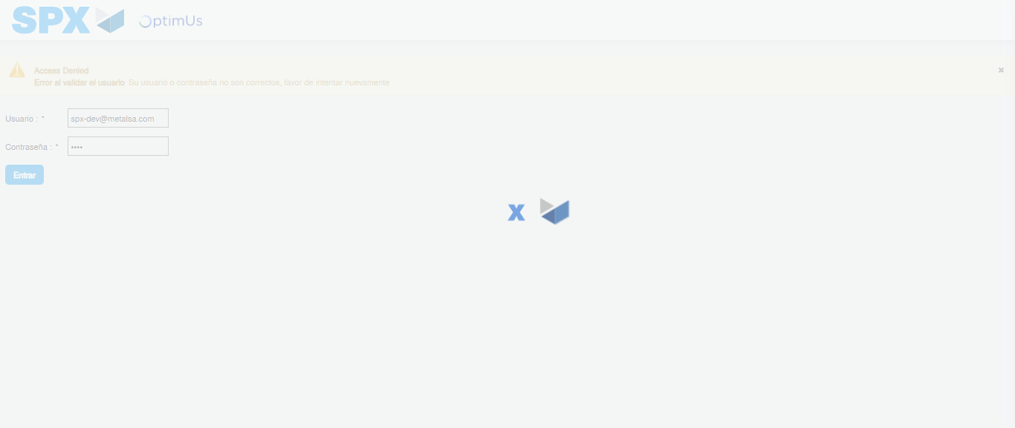Image file-name: QC_Testing-tc002_SPX_Dev5_Crear_Requisicion_Spot_Con_FAD_Tipo_Cobro_CC-1783354547234

Step 2 - Select to UEN and Access to Spot Buy Requisitions : UEN Correctly selected and Correct access
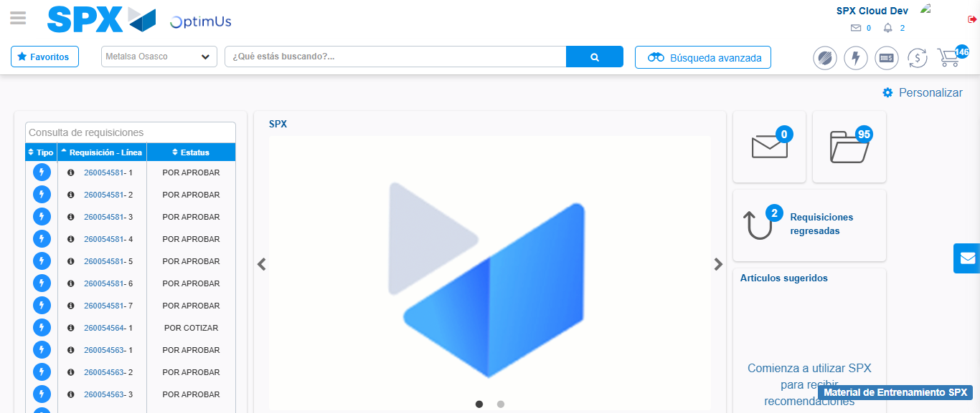Image file-name: QC_Testing-tc002_SPX_Dev5_Crear_Requisicion_Spot_Con_FAD_Tipo_Cobro_CC-1783354572812

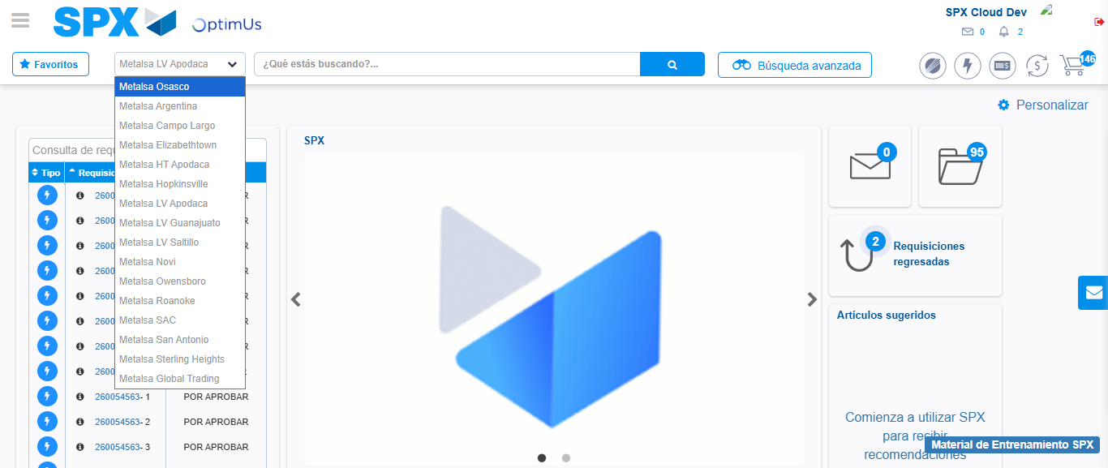Image file-name: QC_Testing-tc002_SPX_Dev5_Crear_Requisicion_Spot_Con_FAD_Tipo_Cobro_CC-1783354575449

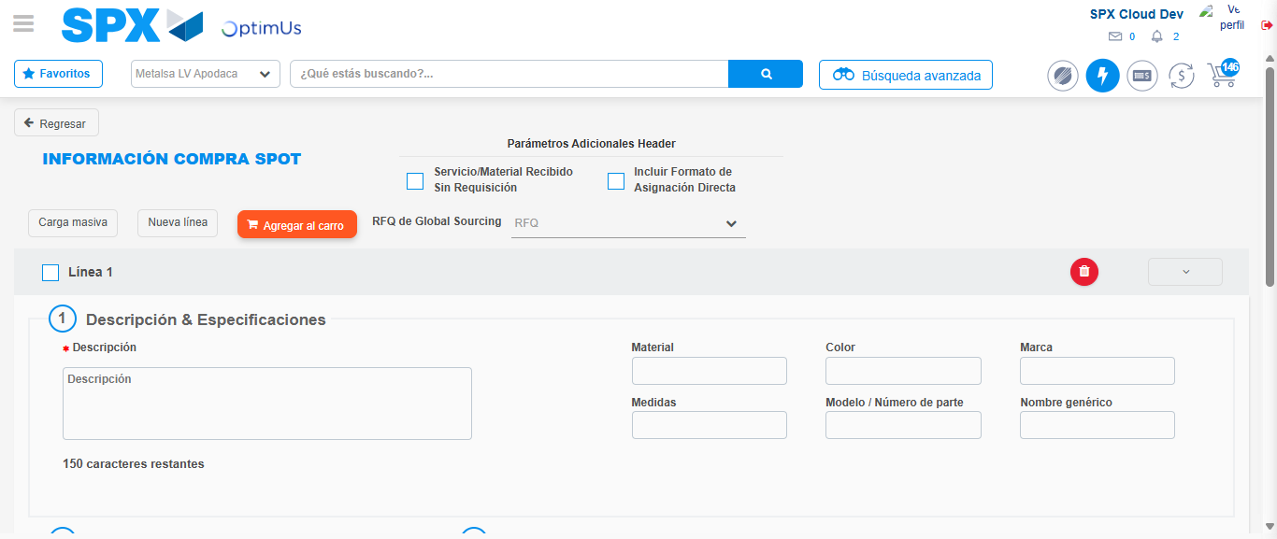Image file-name: QC_Testing-tc002_SPX_Dev5_Crear_Requisicion_Spot_Con_FAD_Tipo_Cobro_CC-1783354594863

Step 3 - Add FAD to Requisition: FAD Successfully Added
Image file-name: QC_Testing-tc002_SPX_Dev5_Crear_Requisicion_Spot_Con_FAD_Tipo_Cobro_CC-1783354595059

Image file-name: QC_Testing-tc002_SPX_Dev5_Crear_Requisicion_Spot_Con_FAD_Tipo_Cobro_CC-1783354595202

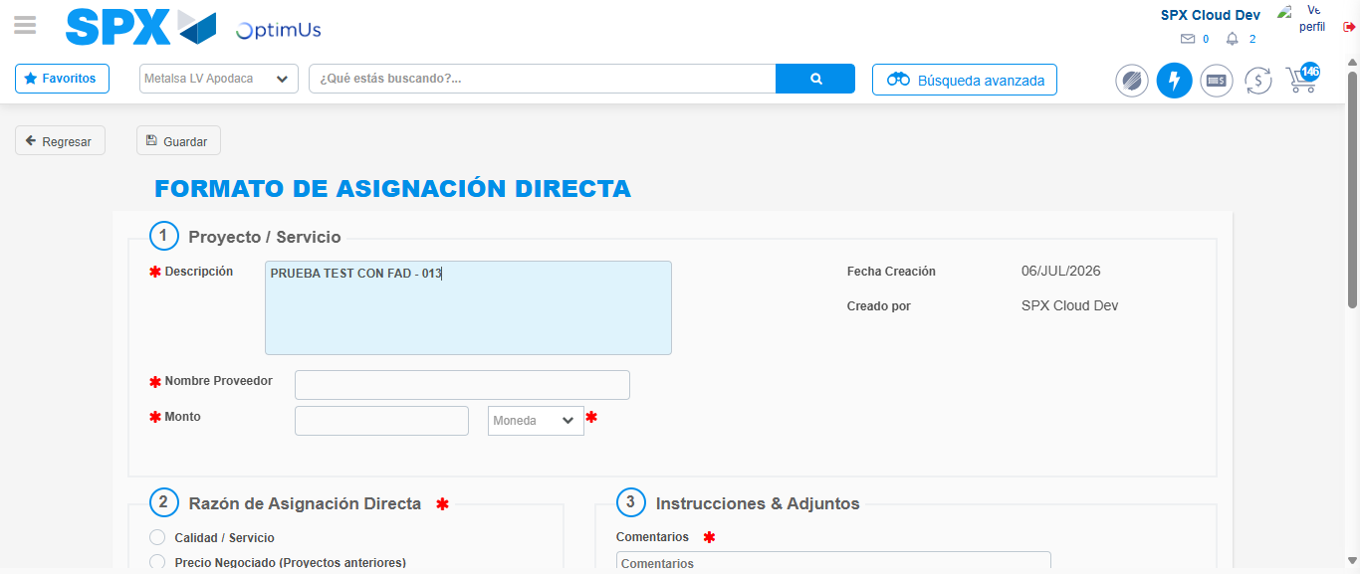Image file-name: QC_Testing-tc002_SPX_Dev5_Crear_Requisicion_Spot_Con_FAD_Tipo_Cobro_CC-1783354597977

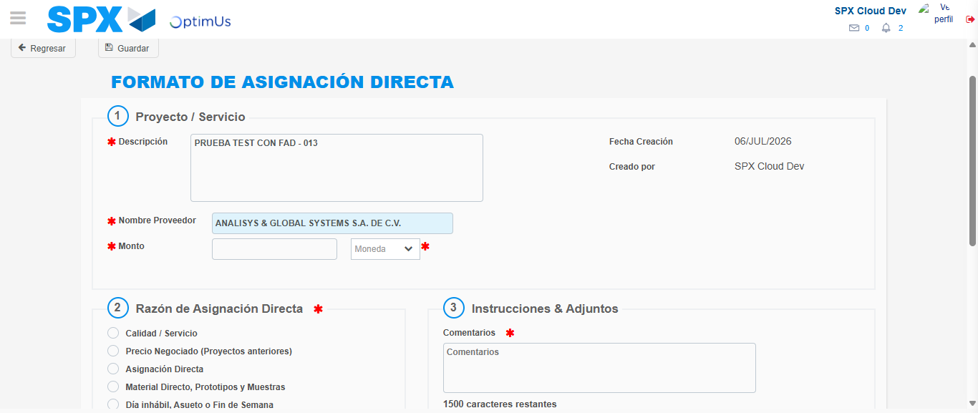Image file-name: QC_Testing-tc002_SPX_Dev5_Crear_Requisicion_Spot_Con_FAD_Tipo_Cobro_CC-1783354604416

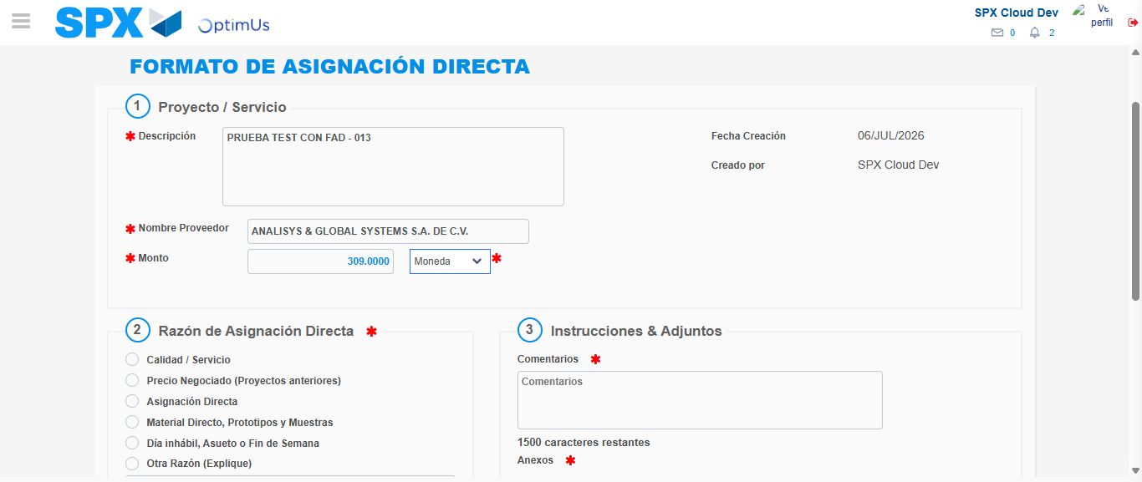Image file-name: QC_Testing-tc002_SPX_Dev5_Crear_Requisicion_Spot_Con_FAD_Tipo_Cobro_CC-1783354604789

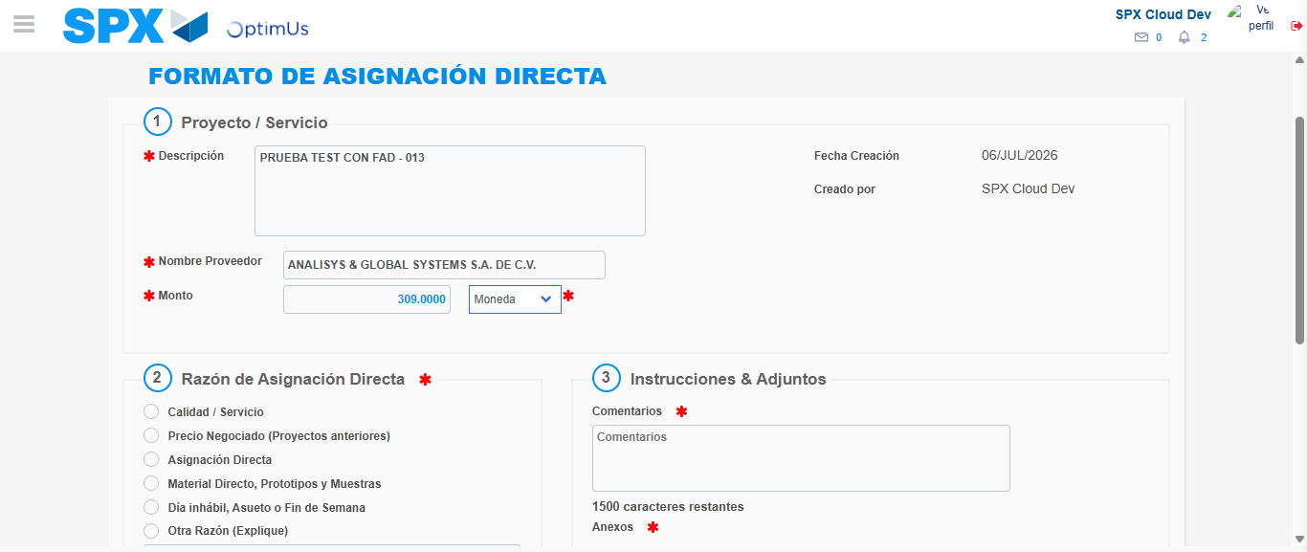Image file-name: QC_Testing-tc002_SPX_Dev5_Crear_Requisicion_Spot_Con_FAD_Tipo_Cobro_CC-1783354604962

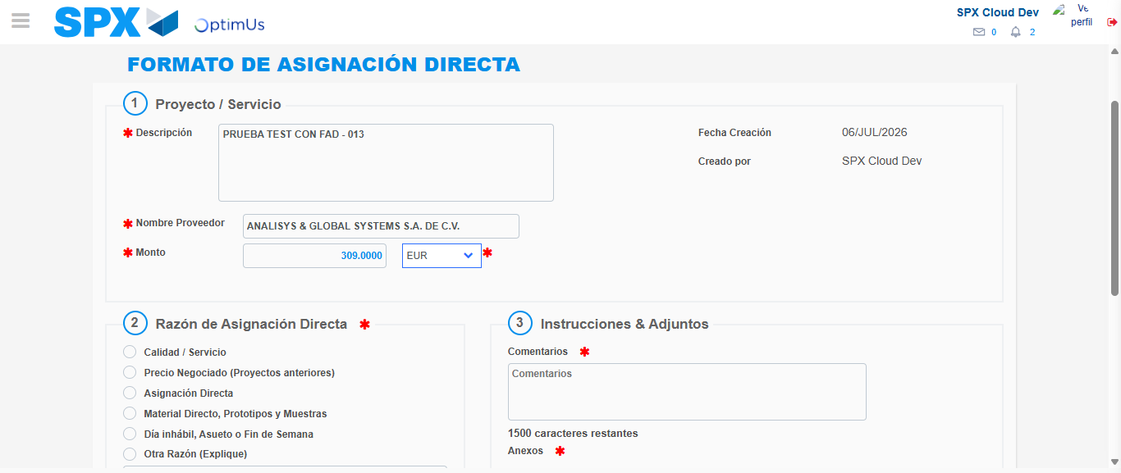Image file-name: QC_Testing-tc002_SPX_Dev5_Crear_Requisicion_Spot_Con_FAD_Tipo_Cobro_CC-1783354605443

Image file-name: QC_Testing-tc002_SPX_Dev5_Crear_Requisicion_Spot_Con_FAD_Tipo_Cobro_CC-1783354605610

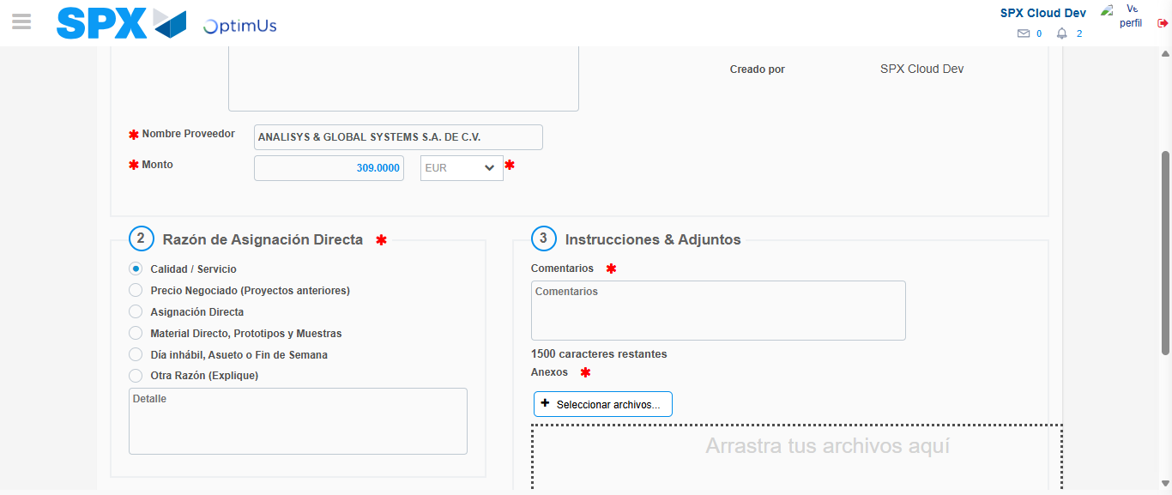Image file-name: QC_Testing-tc002_SPX_Dev5_Crear_Requisicion_Spot_Con_FAD_Tipo_Cobro_CC-1783354606492

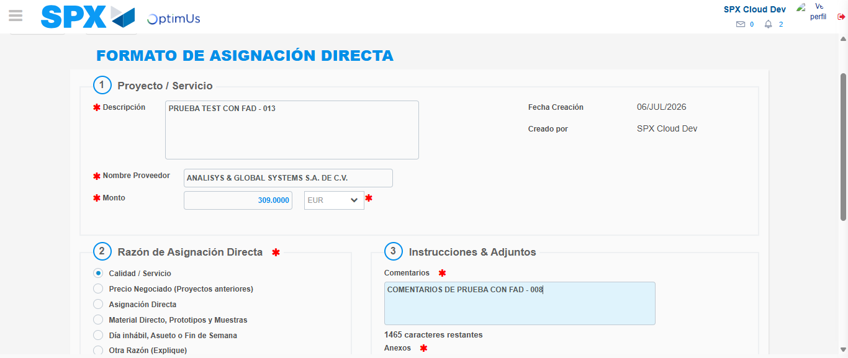Image file-name: QC_Testing-tc002_SPX_Dev5_Crear_Requisicion_Spot_Con_FAD_Tipo_Cobro_CC-1783354617486

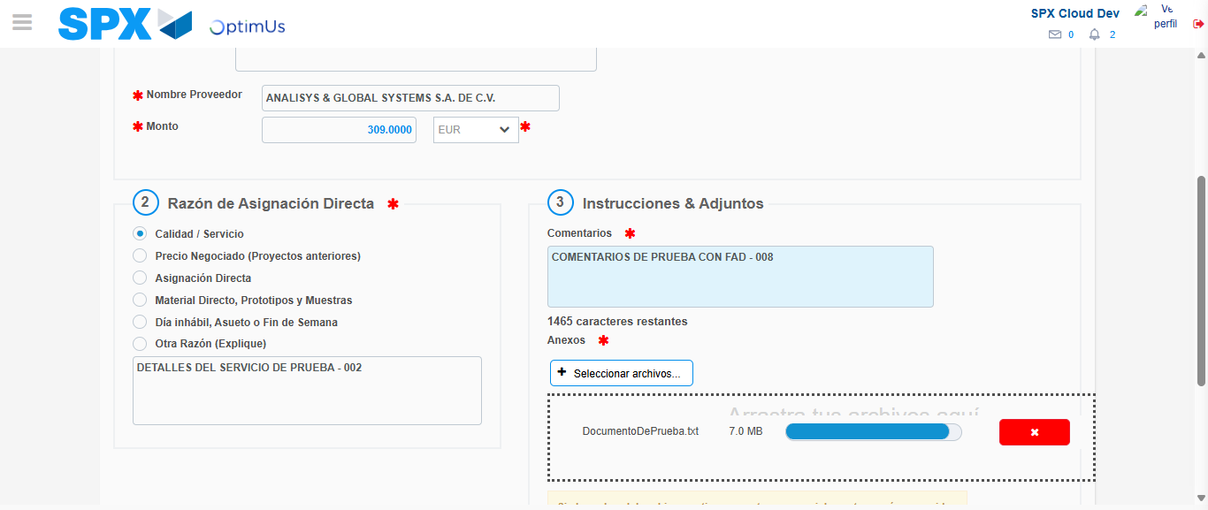Image file-name: QC_Testing-tc002_SPX_Dev5_Crear_Requisicion_Spot_Con_FAD_Tipo_Cobro_CC-1783354618147

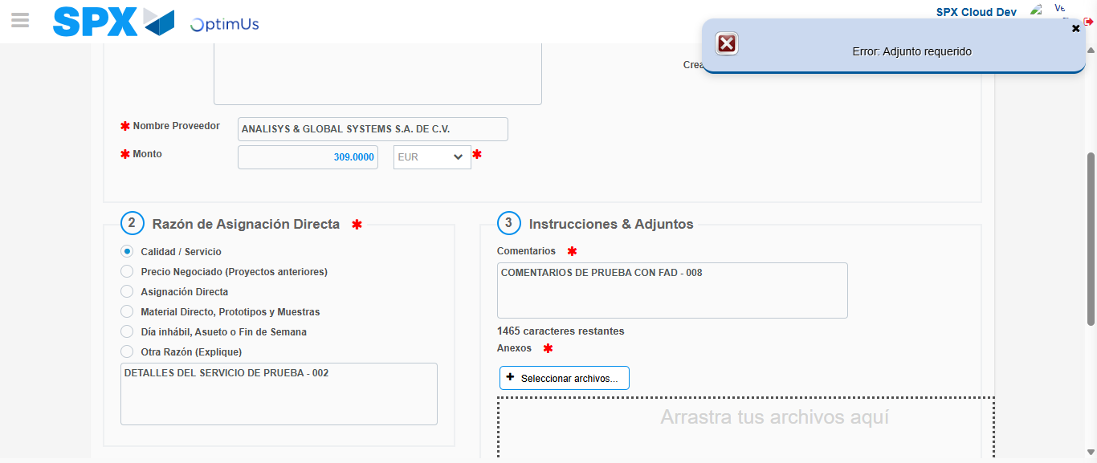Image file-name: QC_Testing-tc002_SPX_Dev5_Crear_Requisicion_Spot_Con_FAD_Tipo_Cobro_CC-1783354619331

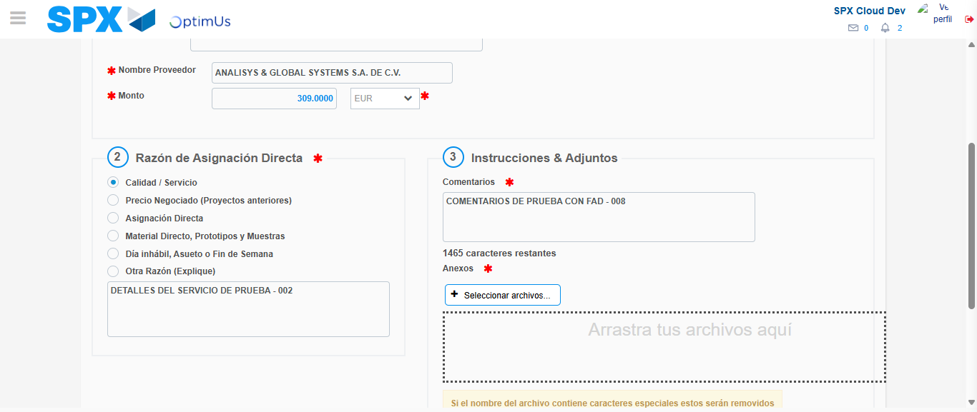Image file-name: QC_Testing-tc002_SPX_Dev5_Crear_Requisicion_Spot_Con_FAD_Tipo_Cobro_CC-1783354619540

Step 4 - Data Capture Spot Buy Requisition: Data captured correctly
Image file-name: QC_Testing-tc002_SPX_Dev5_Crear_Requisicion_Spot_Con_FAD_Tipo_Cobro_CC-1783354595059

Image file-name: QC_Testing-tc002_SPX_Dev5_Crear_Requisicion_Spot_Con_FAD_Tipo_Cobro_CC-1783354595202

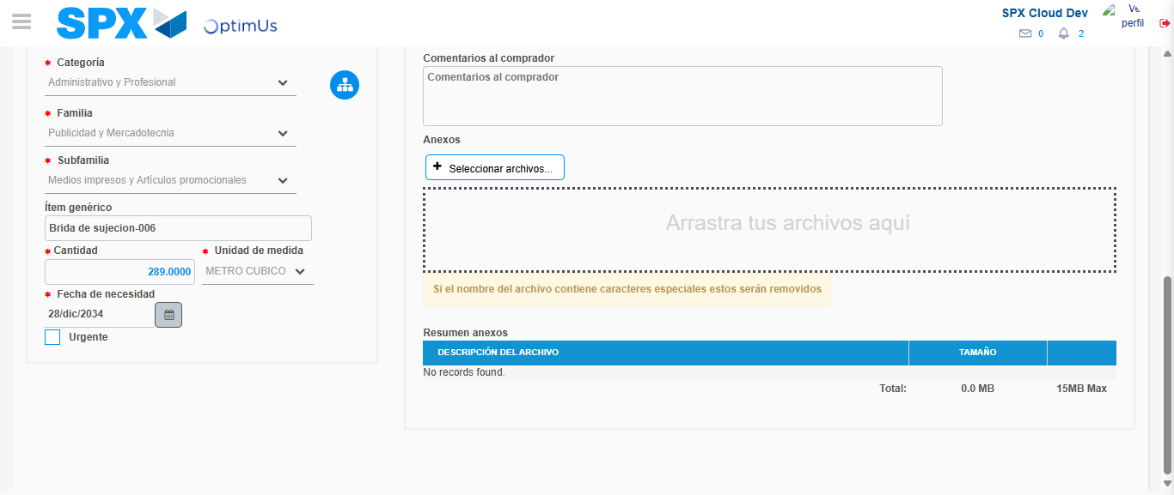Image file-name: QC_Testing-tc002_SPX_Dev5_Crear_Requisicion_Spot_Con_FAD_Tipo_Cobro_CC-1783354631906

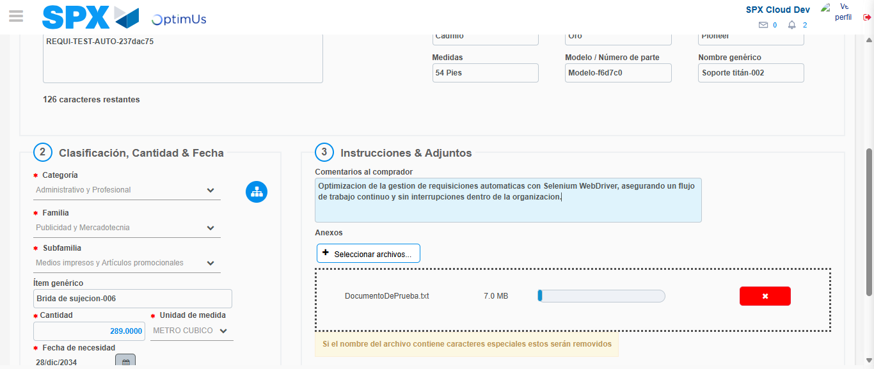Image file-name: QC_Testing-tc002_SPX_Dev5_Crear_Requisicion_Spot_Con_FAD_Tipo_Cobro_CC-1783354632707

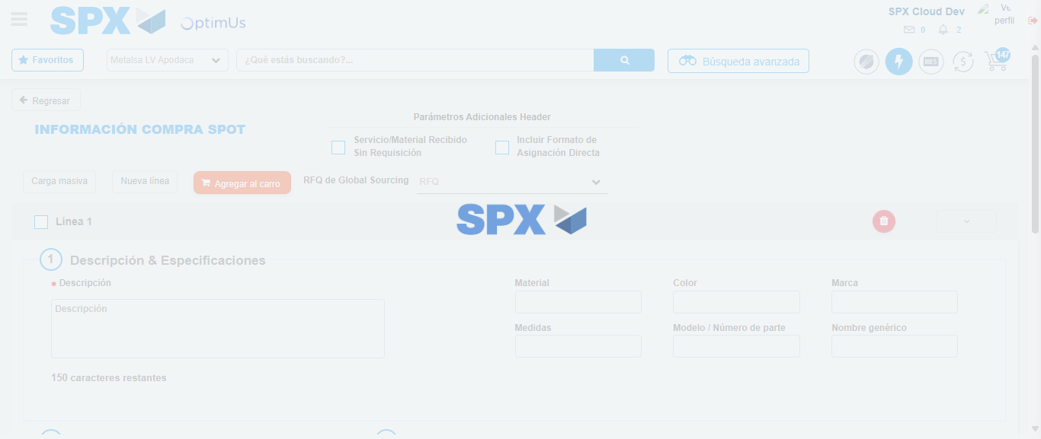Image file-name: QC_Testing-tc002_SPX_Dev5_Crear_Requisicion_Spot_Con_FAD_Tipo_Cobro_CC-1783354638402

Step 8 - Return to Main Page SPX : Return to Main Page SPX
Image file-name: QC_Testing-tc002_SPX_Dev5_Crear_Requisicion_Spot_Con_FAD_Tipo_Cobro_CC-1783354572812

Image file-name: QC_Testing-tc002_SPX_Dev5_Crear_Requisicion_Spot_Con_FAD_Tipo_Cobro_CC-1783354575449

Image file-name: QC_Testing-tc002_SPX_Dev5_Crear_Requisicion_Spot_Con_FAD_Tipo_Cobro_CC-1783354594863

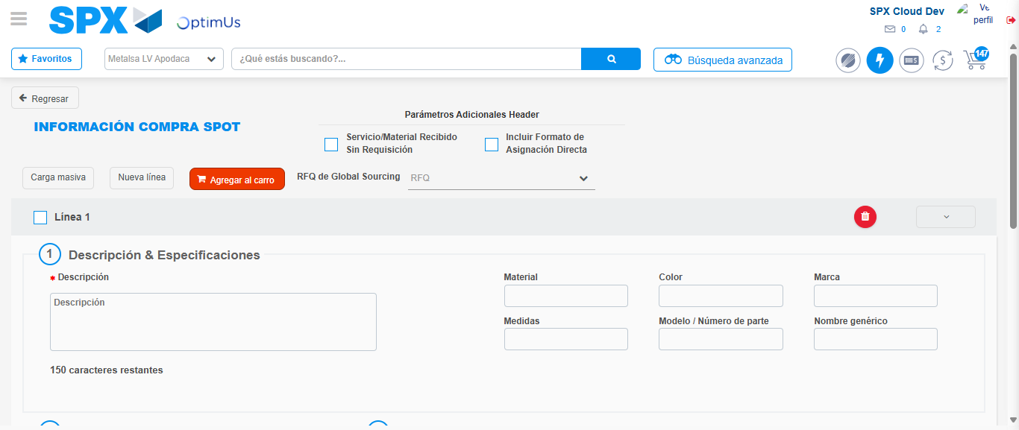Image file-name: QC_Testing-tc002_SPX_Dev5_Crear_Requisicion_Spot_Con_FAD_Tipo_Cobro_CC-1783354640592

Image file-name: QC_Testing-tc002_SPX_Dev5_Crear_Requisicion_Spot_Con_FAD_Tipo_Cobro_CC-1783354640729

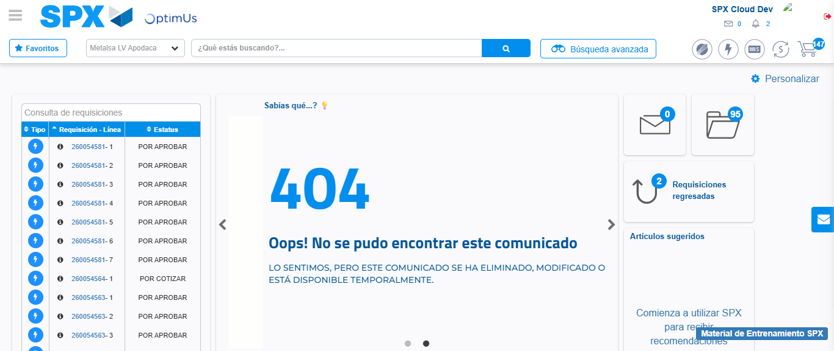Image file-name: QC_Testing-tc002_SPX_Dev5_Crear_Requisicion_Spot_Con_FAD_Tipo_Cobro_CC-1783354661833

Step 9 - Log Out : Log Out SPX
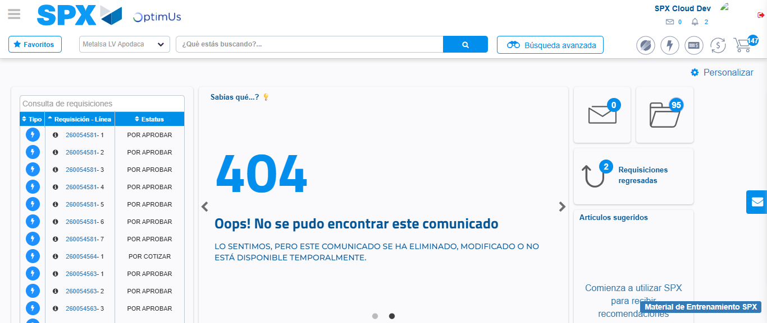Image file-name: QC_Testing-tc002_SPX_Dev5_Crear_Requisicion_Spot_Con_FAD_Tipo_Cobro_CC-1783354662112

